Welcome to a new school year! I am so excited to be teaching at Old Mill Elementary! I will sending home newsletters every week to provide families with information about what the students are learning in the classroom and upcoming events. Students will be learning the routines and expectations of the classroom, learning each other’s names, and making new friends! Both classes will work to develop rules for school. The class rules are: 1.Listening Ears, 2.Walking Feet 3. Watching Eyes 4. Quiet Mouth 5. Be kind and respectful! We will be focusing on Back to School for the theme this week. earning the routines and expectations of the classroom, learning each other’s names, and making new friends! Both classes worked to develop rules for school. The class rules are:

1. Listening Ears
2. Watching Eyes
3. Walking Feet
4. Quiet Mouth
5. Be Respectful!

Ms. Mills’ Class Newsletter, August 21-23

**Important Dates:**

**September 3rd: No School, Labor Day Holiday**

**September 4th: No School, Teacher Planning Day**

Reminders:

Adults listed on the transportation form **must** have a photo identification in order to pick up your child from school or the bus stop.

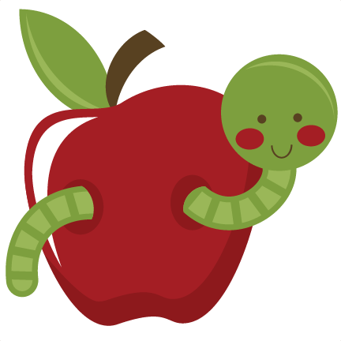

Social Studies: 1. I can put our school day in order.

2. I can tell you about myself.

**Sea Turtle News:**

We adopted a Kemp’s Ridley sea turtle from The Turtle Hospital in Marathon, Florida. Her name is Bender, and she will be sending us letters each month to tell us how she is doing and what it’s like to be a sea turtle! We love having a sea turtle pen pal! I will post the letters that Bender sends us outside the classroom door for families to see!

**Ideas for home:** Practice counting to ten every day! Use toys or small snacks like Goldfish to have your child practice to count each item and point each one.

Books We are Reading:

This week our focus is Back to School. We will be reading several books that help children learn about school expectations and how to be a good friend. We will be reading Biscuit Goes to School, Curious George Goes to School, Boomer Goes to School, Cool Dog School Dog, Caillou Show and Tell, Countdown to Kindergarten, Ribbit, and Not Quite Narwhal.

