We had a wonderful first week of school! The students are doing a very nice job with learning the routines and expectations of the classroom. The children are also learning the rules of the classroom. I have heard so many students say kind and respectful things to one another. We have also been seeing wonderful friendships forming in the classroom. We are continuing to focus on the Back to School theme for this week. We have been listening to many stories about animals and children going to school.r school. The class rules are:

1. Listening Ears
2. Watching Eyes
3. Walking Feet
4. Quiet Mouth
5. Be Respectful!

Ms. Mills’ Class Newsletter, August 27-30

**Important Dates:**

**September 3rd: No School, Labor Day Holiday**

**September 4th: No School, Teacher Planning Day**

Reminders:

Adults listed on the transportation form **must** have a photo identification in order to pick up your child from school or the bus stop.

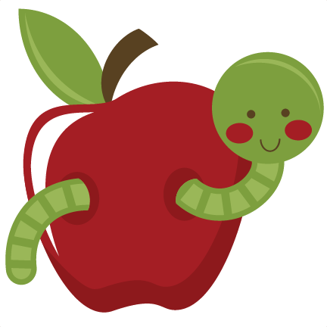

Social Studies: 1. I can put our school day in order.

2. I can tell you about myself.

**Sea Turtle News:**

We read our first letter from our pen pal, Bender the sea turtle. We love hearing all about Bender and what sorts of things she likes to do at The Turtle Hospital. We can’t wait to hear from her again soon!

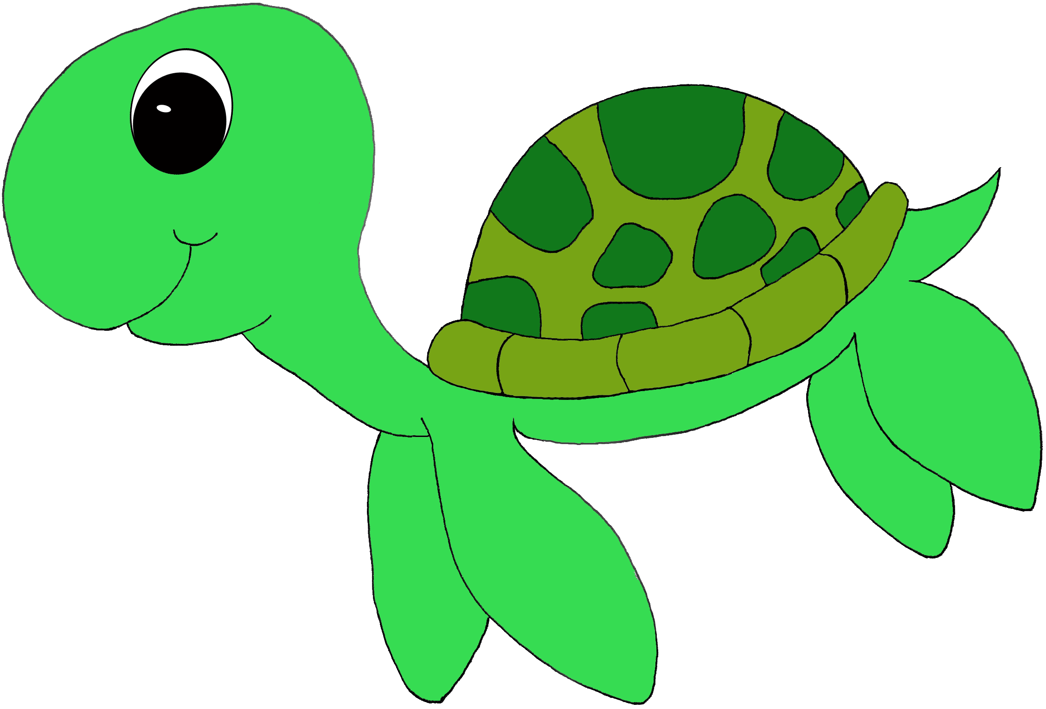

**Ideas for home:**

Have your child tell you a story with their drawing. Ask them about their picture, and see if they can tell you all about it.

Books We are Reading:

We are continuing to focus Back to School this week. We will be reading several books that help children learn about school expectations and how to be a good friend. We will be reading Biscuit Goes to School, Curious George Goes to School, Cool Dog School Dog, Caillou Show and Tell, and Countdown to Kindergarten.

