Hello HELC families! We are a couple of weeks into the school year, and we are seeing great growth and wonderful friendships forming. The children have been learning procedures and school readiness skills, such as standing in line quietly, lining up after recess, and raising their hand to share in class. We have also been working on sharing and using kind words to one another.

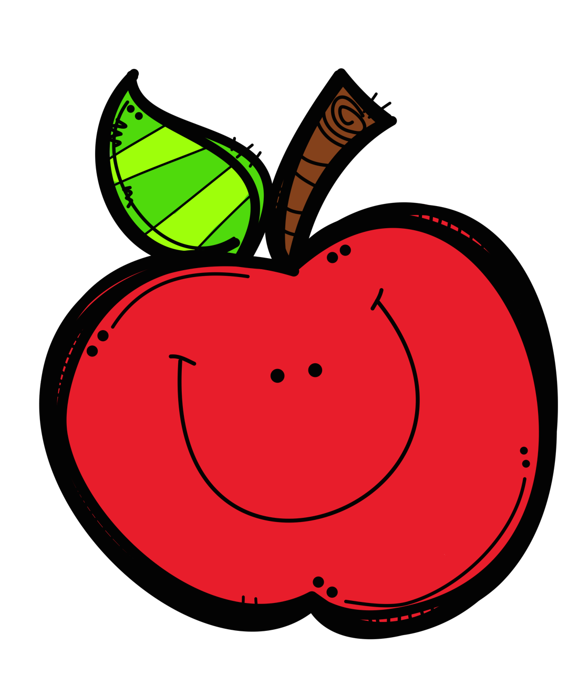

Ms. Mills’ Class Newsletter, September 18- 30

Reminders:

Adults listed on the transportation form **must** have a photo identification in order to pick up your child from school or the bus stop.

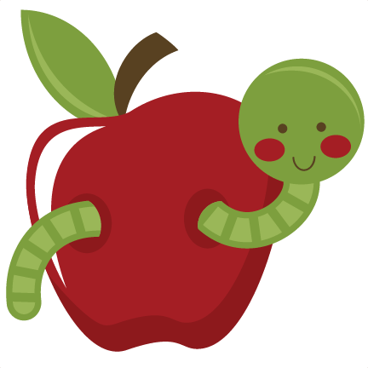

Social Studies: 1. I can put our school day in order.

2. I can tell you about myself.

**Important Dates:**

**October 1-5: No school, Fall Break**

**October 8th: No School, Teacher Planning**

**Sea Turtle News:**

Bender, our sea turtle, is continuing to do well! The staff at The Turtle Hospital take great care of her! We will be setting up a time to do a Skype session with her soon! 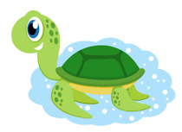

**Books We Are Reading:**

I Like Myself!, Little Louie the Baby Bloomer, Say Please, One For You, One for Me.



**Ideas for home:** Try sorting at home! See if your child can sort objects (like toys or snacks) by color, size, or shape.Another fun idea is to go on a nature walk and collect leaves. Work with your child to sort the leaves by colors, shapes, and sizes!

