Hello preschool families! This week we are continuing our focus on All About Me. This week, students will listen to the story “The Rainbow Fish”. We will listen how the Rainbow Fish does not like to share, and how that impacts her friendships. Later on the story, the Rainbow Fish decides to share and it helps her to become a better friend. We will discuss these concepts together as a class. Students will also have the opportunity to create their own fish, complete with a sparkly scale, just like in the story. Students will also share examples of how they can and have been sharing in the classroom.

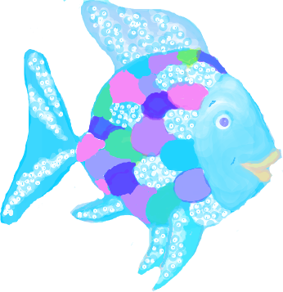

Ms. Mills’ Class Newsletter, September 10-15

Reminders:

Adults listed on the transportation form **must** have a photo identification in order to pick up your child from school or the bus stop.

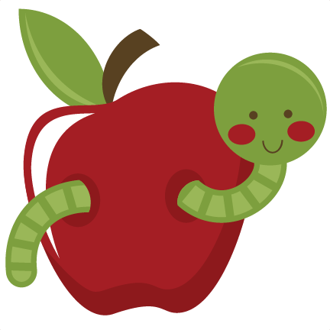

Social Studies: 1. I can put our school day in order.

2. I can tell you about myself.

**Important Dates:**

**October 1-5: No school, Fall Break**

**October 8th: No School, Teacher Planning**

**Sea Turtle News:**

The students ask about Bender, our class sea turtle every day. She is continuing to do well at The Turtle Hospital!

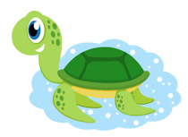

**Books We Are Reading:**

The Rainbow Fish, Harold and the Purple Crayon, Leo the Late Bloomer, Little Louie the Late Bloomer



**Ideas for home:** Try patterning at home! See if your child can make a pattern with different color blocks. Start with two colors, and then three. Work on different types of patterns, such as AB patterns and ABC patterns!

