Hello preschool families! We are having a wonderful time in preschool!   
The students have adjusted well with the transition back to school, and we are more settled in our classroom routines. This week, we will be focusing on introducing feelings to the students. As a part of our Conscious Discipline curriculum, students are taught about emotions and feelings and how to manage them in an effective manner. This week we will be focusing on happy and sad. We will also be discussing self-talk to help encourage ourselves to get through challenging tasks. We will be practicing those self-talk skills while working on sorting and patterning.



Ms. Mills’ Class Newsletter, September 17-21

Reminders:

Adults listed on the transportation form **must** have a photo identification in order to pick up your child from school or the bus stop.

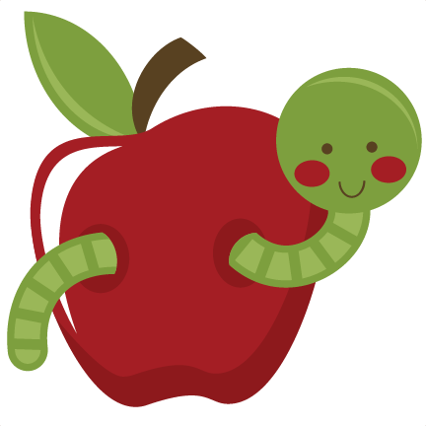

Social Studies: 1. I can put our school day in order.

2. I can tell you about myself.

**Important Dates:**

**October 1-5: No school, Fall Break**

**October 8th: No School, Teacher Planning**

**Sea Turtle News:**

Bender, our sea turtle, is continuing to do well! The staff at The Turtle Hospital take great care of her! We will be setting up a time to do a Skype session with her soon! 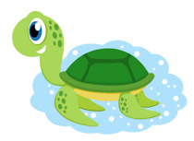

**Books We Are Reading:**

Llama Llama Red Pajama, You Are My Sunshine, Feelings, Do You Want to Be My Friend?



**Ideas for home:** Try patterning at home! See if your child can make a pattern with different color blocks. Start with two colors, and then three. Work on different types of patterns, such as AB patterns and ABC patterns!

