Mrs. Mills’ Class Newsletter, September 24-28 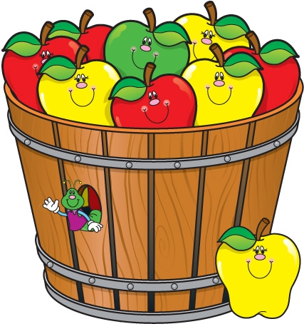

Hello preschool families! We are having a wonderful time in preschool!   
This week, we will continue to focus on sorting and patterning. The students have really enjoyed learning about sorting and patterning, and have already shown a lot of growth in this area!

Big news! We would like to welcome the new assistant in our classroom! Her name is Cara Hall and we just love her! She is so wonderful with the students, and makes everyone feel welcome and at home at school. Welcome Ms. Cara!

Literacy is such an important component of a child’s growth and overall development. To promote literacy, I will be sending home newsletters each month with information regarding literacy, or articles that outline books that focus on certain subjects that children will love. It is my goal to increase literacy awareness in the classroom, and to provide families with information to help increase literacy at home as well! I will also be sending home information about Epic!, a place where you can log on online and read books to your child. This is a wonderful program to provide a variety of books to students and families!

**Important Dates:**

**October 1-5: No school, Fall Break**

**October 8th: No School, Teacher Planning**

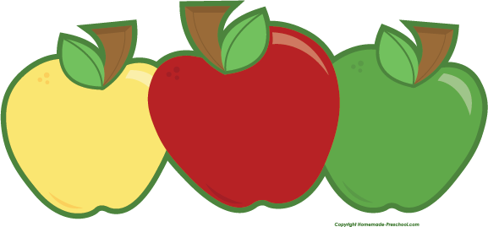

Reminders:

Adults listed on the transportation form **must** have a photo identification in order to pick up your child from school or the bus stop.

Please be sure to put a change of clothes in your child’s backpack in case of accidents or spills. Please include shirt, underwear, pants, and socks. Place these items in a gallon size ziplock bag and leave in your child’s backpack. By leaving them in the backpack, you can change out the clothes as the seasons change and your child grows. This will help us out tremendously. Thank you so much!

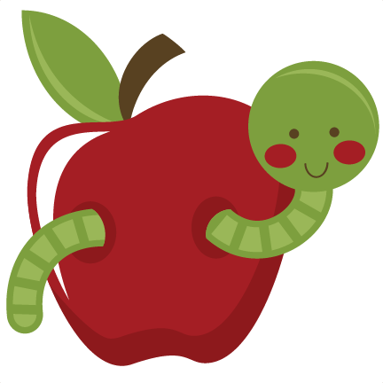

Social Studies: 1. I can put our school day in order.

2. I can tell you about myself.

**Sea Turtle News:**

Bender gave us an update! She loves eating jellyfish!

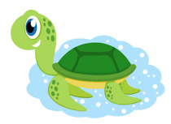

**Ideas for home:** Check out Epic! This provides online books for you to read with your child for free! Let us know which books are your child’s favorite!

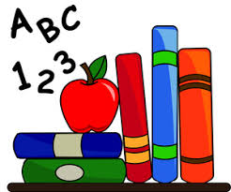

**Books We Are Reading:**

Harold and the Purple Crayon, Chalk!, Ellie, Harry’s House

